S. No. | Events/  Game | No. | Athletics  Name | Events | University Name | Athletics Pictures
1 | Boxing |  | Simranjit  Kaur | Women's, 60kg | Punjabi Univ. Patiala | 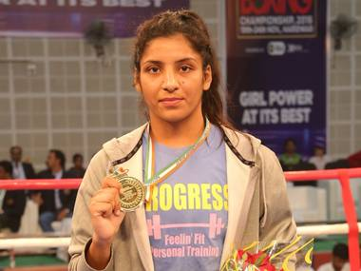
2 | Fencing |  | Bhavani  Devi |  | G.N.D.U AMRITSAR /KIIT Univ. | 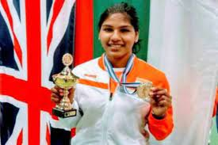
3 | Shooting |  | Anjum  Moudgil | 10m Women’s Air Rifle | Punjab University, Chandigarh | 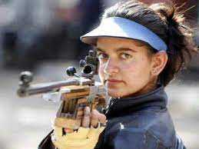
 |  |  | Divyansh  Singh  Panwar | 10m Men’s Air Rifle | G.N.D.U AMRITSAR | 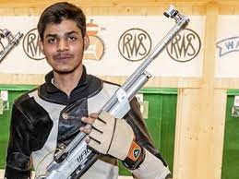
 |  |  | Aishwarya  Pratap  Singh  Tomar | 50m Men’s Rifle 3 Position | G.N.D.U AMRITSAR | 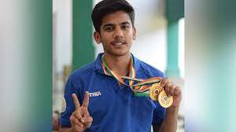
 |  |  | Manu  Bhaker | 10m Women’s Air Pistol | Delhi university | 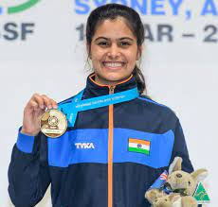
 |  |  | Yashaswini Singh  Deswal | 10m Women’s Air Pistol | Punjab University, Chandigarh | 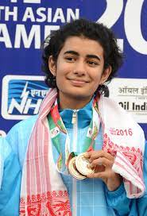
 |  |  | ElavenilValarivan | 25m Women’s Pistol | Gujarat University | 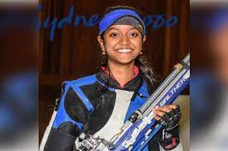
 |  |  | Angad  Veer  Singh  Bajwa | Men’s Skeet | Manav Rachna Univ. | 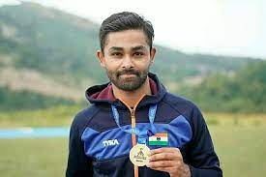
4 | Hockey Men |  | HARMAN PREET  SINGH |  | G.N.D.U AMRITSAR | 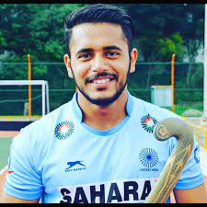
 |  |  | MAN  PREET  SINGH |  | G.N.D.U AMRITSAR | 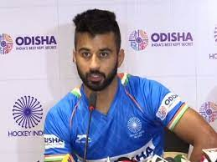
 |  |  | HARDIK  SINGH |  | G.N.D.U AMRITSAR | 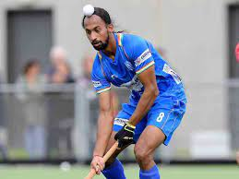
 |  |  | SHAMSHER SINGH |  | G.N.D.U AMRITSAR | 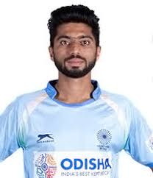
 |  |  | GURJANT SINGH |  | G.N.D.U AMRITSAR | 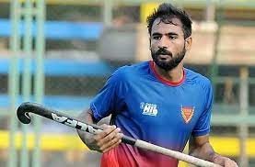
 |  |  | DILPREET SINGH |  | G.N.D.U AMRITSAR | 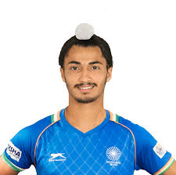
5 | Hockey Women |  | RANI |  | Punjabi Univ. Patiala | 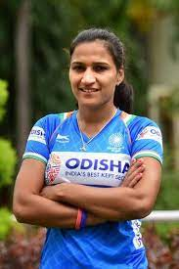
 |  |  | RAJWINDER KAUR |  | Punjabi Univ. Patiala | 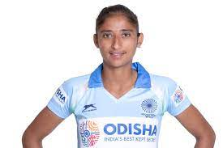
6 | Swimming |  | Srihari  Natraj |  | Jain University | 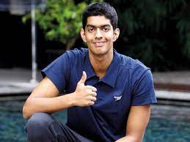
7 | Golf |  | Aditi  Ashok |  | Jain Deemed unive rsity | 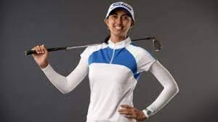
8 | Para Olympic |  | Aruna  Tanwar | Taekwondo | Chandigarh University | 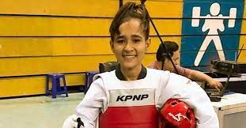
 |  |  | Nishad Kumar | High Jump | LPU | 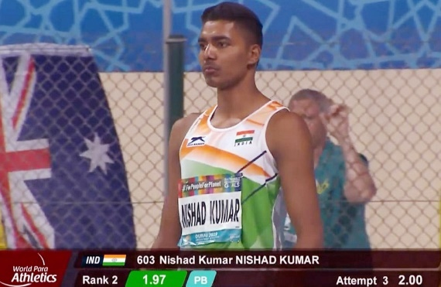
9 | Archery |  | Pravin Jadhav | Men’s Recurve | SGB, Amravati | 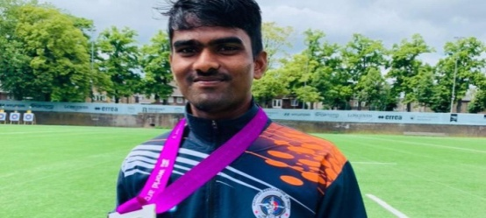
10 | Athletics |  | Murali Sreeshankar | Men's long jump | Lovely Professional University, Punjab | 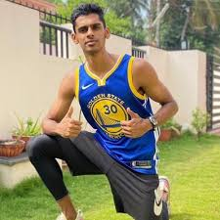
 |  |  | Neeraj Chopra | Men's javelin throw | Panjab Univ., Chandigarh | 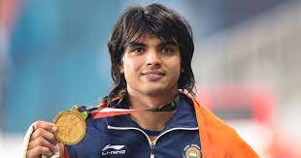
 |  |  | Shivpal Singh | Men's javelin throw | KIIT Univ. | 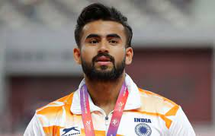
 |  |  | Tajinderpal  Singh Toor | Men's shot put | Punjabi Univ. Patiala | 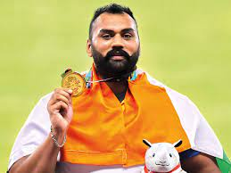
 |  |  | Kamalpreet  Kaur | Women's discus throw | Punjabi Univ. Patiala | 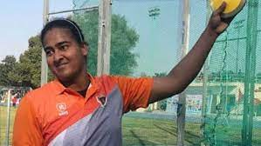
 |  |  | Priyanka Goswami | Women's 20km race walking | Punjabi Univ. Patiala | 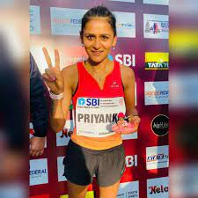
 |  |  | Dutee  Chand | 100m & 200m | KIIT Univ. | 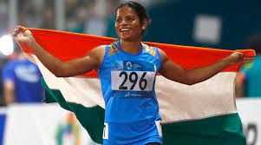
 |  |  | Vismaya VK |  | MGU, Kotayam | 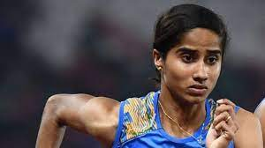
 |  |  | M. V Jabbir | 400 mtr Hurdle | MGU, Kotayam | 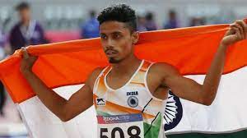
 |  |  | Ms. ANNU RANI | Javelin Throw | CCSU, Meerut | 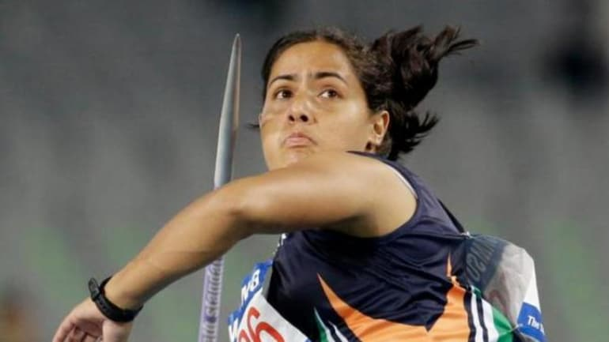
 |  |  | Amoj Jacob | 4X400m Relay Men | LPU | 